Stanley Kubrick
Hannah Assefa

Stanley Kubrick made a big impact on cinema in the 20th century. He became a photographer at the early age of seventeen and began filmmaking at twenty-two. From there his career would skyrocket, leading on to some of the greatest classics still remembered today.

BIO
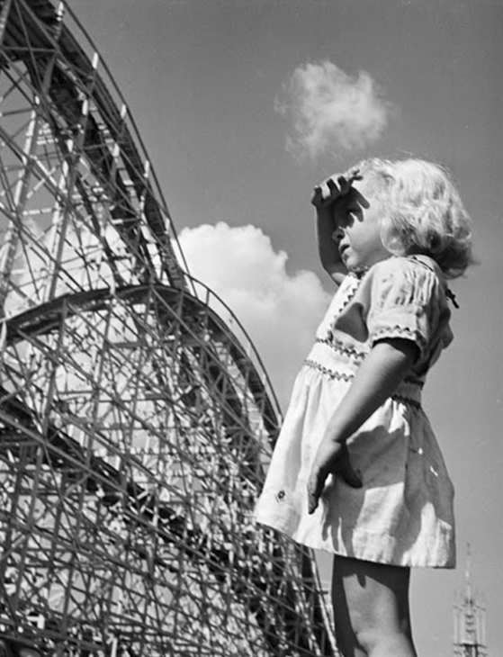
Surmane ( yesr ) Kubrick was born On July 26th 1928 in New York city. He was seen as an intelligent child despite his low grades in school, so his father introduced him to chess, which led to a passion for the game and would aid him instead as a tool for his future career. At the age of thirteen, his father got him his first film camera for photography; from there, Kubrick began taking photos around the city and would develop the photos with a new-found friend (his neighbour) with the same passion for photography and a darkroom they could develop photos in. At the age of seventeen, Kubrick proved himself as a photographer and was accepted a job at ‘Look’ magazine. From there, he would start a 5-year career in photography and take at least
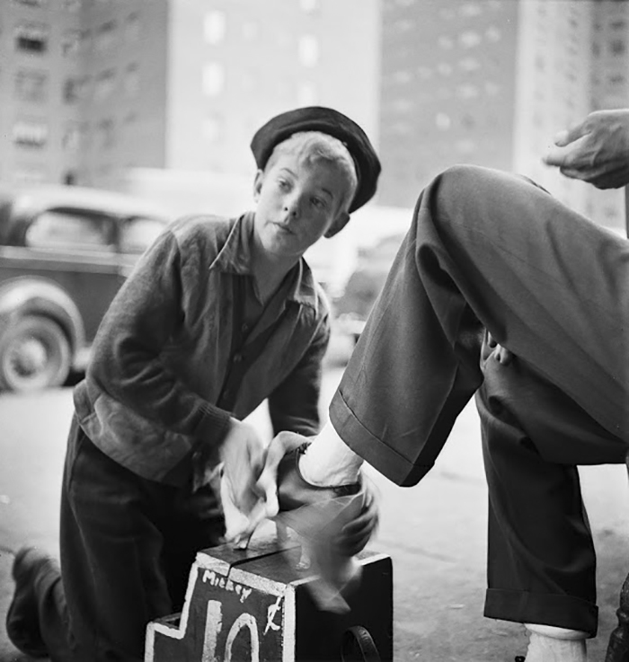
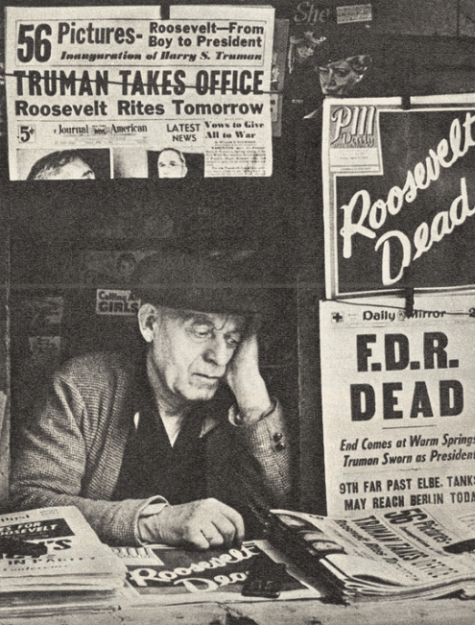
Newspaper man, ‘Roosevelt dead’ Shoe-Shiner, New York city, Young girl in
Photo taken in 1945 ( 1946 Palisades park, New
Jersey, 1946

In that time as a photographer, he became infatuated with moving pictures and with the help of his friend ‘Alexander Singer’, he would pursue this new profession. With the money he saved from his photography career, from 1950 he would save money for and create the documentary ‘Day of the fight’ which would be released in 1951, the same year, he would make his next documentary called ‘Flying Padre’ and in 1953 he would release ‘The Seafarers’ and ‘Fear and desire’ which this time was not a documentary but instead a thriller/war movie.

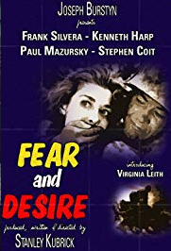
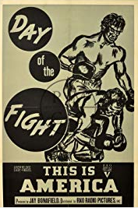

Kubrick went on to direct many other movies such as ‘killer’s kiss,’ ‘The killing.’ The movies that made him noticed in the film industry were ‘Paths of glory’ and ‘Spartacus,’ both movies that kickstarted his career as a director and filmmaker. Spartacus is possibly one of his most popular movies directed; It was in fact Kirk Douglas (who also played in ‘Paths of Glory’) who prompted him to direct the film. Although some of the crew members on set did not agree with his directing strategies in the movie, that did not stop Kubrick’s work and efforts he put into the production of the film. In 1961, the film got four academy awards and one Golden Globe award.

Not only did he do direct in the movie but subsequently did cinematography in the movie too. The original Cinematographer’s (Russell Metty) work was not up to Stanley Kubrick’s perfectionist standards for the film, so soon after he took over, this left Russell Metty doing practically nothing for the film and even had to accept a cinematography award for the movie he didn’t have part in.

His earlier movies were what led him to direct some of the most iconic movies in film history.

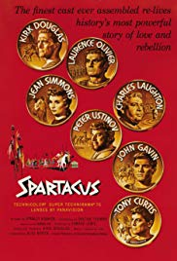
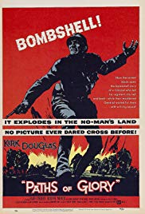

The movie ‘Paths of The movie ‘Spartacus’
Glory’ featuring also featuring Kirk
Kirk Douglas Douglas

Kubrick went on to direct some of the 60’s-70’s classics like ‘2001: Space Odyssey,’ ‘Dr. Strangelove,’ ‘Lolita,’ ‘Barry Lyndon’ and ‘Clockwork Orange.’

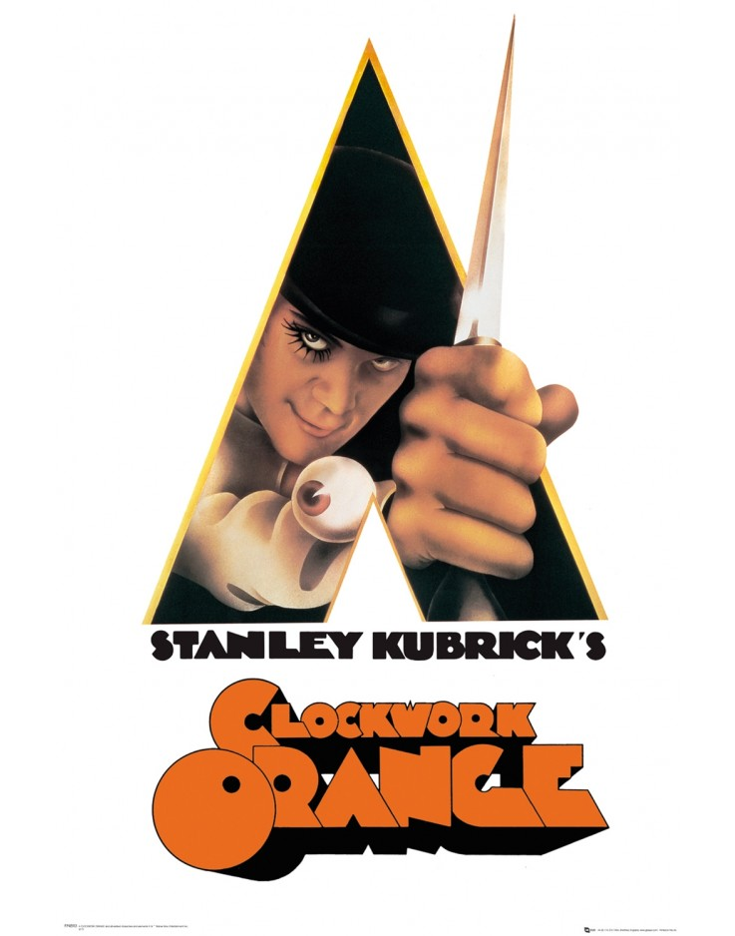

Made in 1971, ‘Clockwork Orange’ is one of Kubrick’s iconic movies made. Clockwork Orange is the movie adaptation of the book which Kubrick read beforehand, the reason he made this into a movie was to prove to others he could make a low budget movie using existing locations, unlike his movie ‘2001: Space Odyssey,’ which cost 10.5 million US dollars ($) to make. He decided to make this movie to prove they don’t have to be so expensive, the film in total cost only 2.2 million dollars. Kubrick scouted London for locations and found many that would work well in the movie.

Stanley Kubrick uses ‘brutalism’ to appeal to the sci-fi nature of the movie. ‘Brutalism’ (also known as ‘Brutalist architecture,’ is a style that began around the 1950s but ended also within the 20th century because the style was ironically ‘brutal’ and unwelcoming in appearance (which is the very reason Stanley Kubrick used these buildings in his movie). The style tends to be ‘blocky’ and geometric in a sense everything that is a brutalist building looks like an abstract statue.

The movie itself is in the sci-fi mystery genre and is based in dystopian England. The story in whole is narrated by the sociopathic gang leader who is also the main character of the film. He’s arrested and rehabilitated through a new ‘therapeutic’ method which goes wrong.

