Stanley Kubrick
Hannah Assefa

Stanley Kubrick made a big impact on cinema in the 20th century. He became a photographer at the early age of seventeen and began filmmaking at twenty-two. From there his career would skyrocket, leading on to some of the greatest classics still remembered today.

BIO
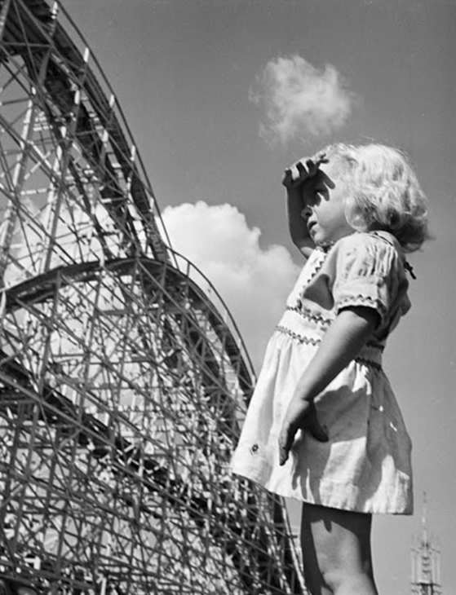

IMDb (2020). Kubrick was born On July 26th 1928 in New York city. He was seen as an intelligent child despite his low grades in school, so his father introduced him to chess, which led to a passion for the game and would aid him instead as a tool for his future career. At the age of thirteen, his father got him his first film camera for photography; from there, Kubrick began taking photos around the city and would develop the photos with a new-found friend (his neighbour) with the same passion for photography and a darkroom they could develop photos in. At the age of seventeen, Kubrick proved himself as a photographer and was accepted a job at ‘Look’ magazine. From there, he would start a 5-year career in photography.
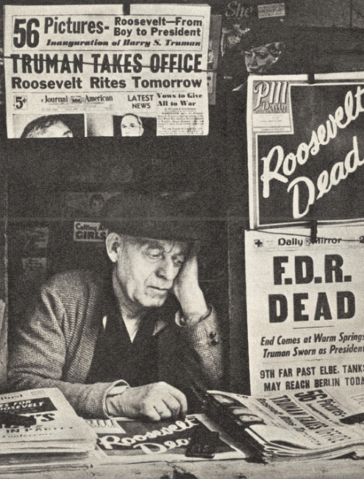
Barber, N. (2018) Andrius (2018) Twistedsifter (2011)
Newspaper man, ‘Roosevelt dead’ Shoe-Shiner, New York city, Young girl in
Photo taken in 1945 1946 Palisades park, New
Jersey, 1946
Career in film
IMDb (2020). In that time as a photographer, he became infatuated with moving pictures and with the help of his friend ‘Alexander Singer’, he would pursue this new profession. With the money he saved from his photography career, from 1950 he would save money for and create the documentary ‘Day of the fight’ which would be released in 1951, the same year, he would make his next documentary called ‘Flying Padre’ and in 1953 he would release ‘The Seafarers’ and ‘Fear and desire’ which this time was not a documentary but instead a thriller/war movie.

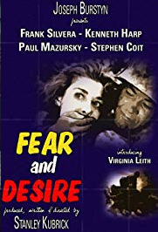
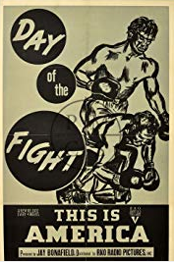

IMDb (2020). Kubrick went on to direct many other movies such as ‘killer’s kiss,’ ‘The killing.’ The movies that made him noticed in the film industry were ‘Paths of glory’ and ‘Spartacus,’ both movies that kickstarted his career as a director and filmmaker. Spartacus is possibly one of his most popular movies directed; It was in fact Kirk Douglas (who also played in ‘Paths of Glory’) who prompted him to direct the film. Although some of the crew members on set did not agree with his directing strategies in the movie, that did not stop Kubrick’s work and efforts he put into the production of the film. In 1961, the film got four academy awards and one Golden Globe award.

IMDb (2020). Not only did he do direct in the movie but subsequently did cinematography in the movie too. The original Cinematographer’s (Russell Metty) work was not up to Stanley Kubrick’s perfectionist standards for the film, so soon after he took over, this left Russell Metty doing practically nothing for the film and even had to accept a cinematography award for the movie he didn’t have part in.

His earlier movies were what led him to direct some of the most iconic movies in film history.

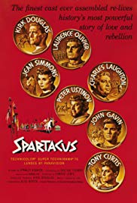
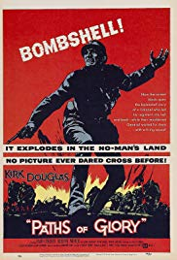

The movie ‘Paths of The movie ‘Spartacus’
Glory’ featuring also featuring Kirk
Kirk Douglas Douglas

Kubrick went on to direct some of the 60’s-70’s classics like ‘2001: Space Odyssey,’ ‘Dr. Strangelove,’ ‘Lolita,’ ‘Barry Lyndon’ and ‘Clockwork Orange.’

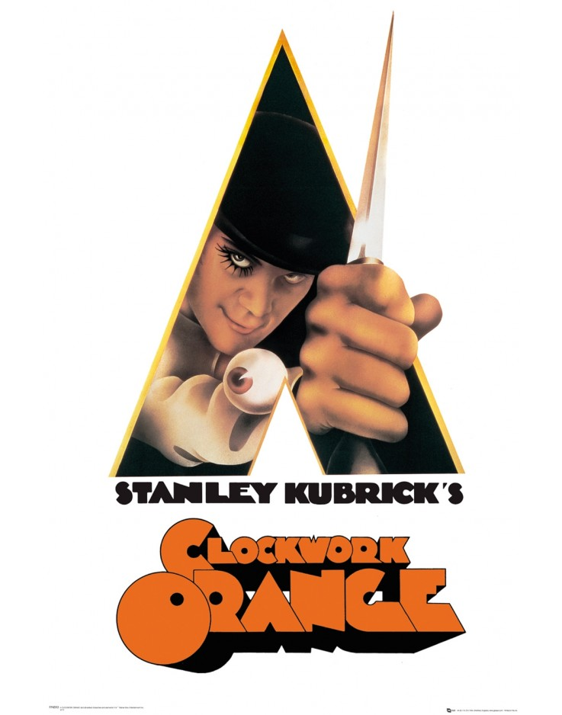

Clockwork Orange Analysis

Movie-Locations (2020). IMDb (2020). Made in 1971, ‘Clockwork Orange’ is one of Kubrick’s iconic movies made. Clockwork Orange is the movie adaptation of the book which Kubrick read beforehand, the reason he made this into a movie was to prove to others he could make a low budget movie using existing locations, unlike his movie ‘2001: Space Odyssey,’ which cost 10.5 million US dollars ($) to make. He decided to make this movie to prove they don’t have to be so expensive, the film in total cost only 2.2 million dollars. Kubrick scouted London for locations and found many that would work well in the movie.

Designing Buildings Wiki (2016). RIBA Architecture (2019). Stanley Kubrick uses ‘brutalism’ to appeal to the sci-fi nature of the movie. ‘Brutalism’ (also known as ‘Brutalist architecture,’ is a style that began around the 1950s but ended also within the 20th century because the style was ironically ‘brutal’ and unwelcoming in appearance (which is the very reason Stanley Kubrick used these buildings in his movie). The style tends to be ‘blocky’ and geometric in a sense everything that is a brutalist building looks like an abstract statue.
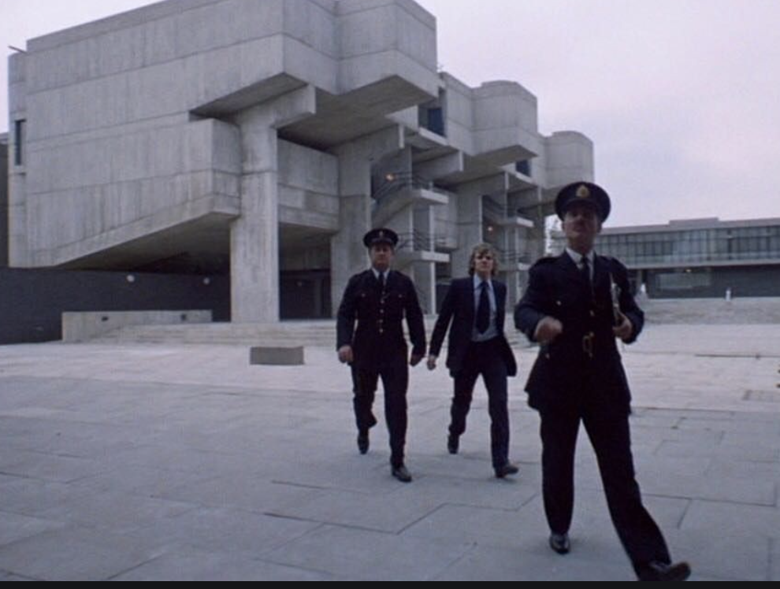
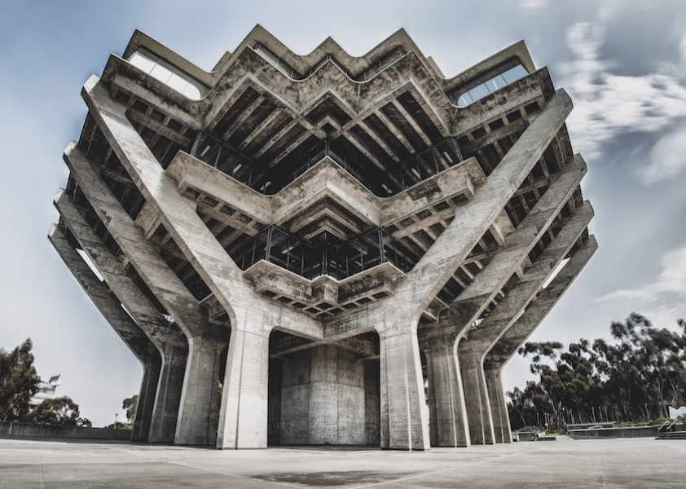

Stewart, J. (2018) Pinterest (2020)

Gallagher, B. (2018). IMDb (2020). The movie itself is in the sci-fi mystery genre and is based in dystopian England. The story in whole is narrated by the sociopathic gang leader (Alex who is played by Malcolm McDowell) and is also the main character of the film. He’s arrested and rehabilitated through a new ‘therapeutic’ method that goes wrong. The cinematography of the movie is simplistic but engaging to the audience, the long shots captured everything in clear view and revealed detail in the film which made it seem so much more realistic, that was what made the movie special.
Feuilleton (2006). IMDb (2020). For example, the record shop scene in the movie was slow paced, the atmosphere was calm but still rather tense considering the scene was in public and the character unpredictable, when Alex passes the counter facing right in front of the camera, below you can see a reference to his last movie, a simple poster that read ‘2001.’ (In reference to ‘2001: Space Odyssey).

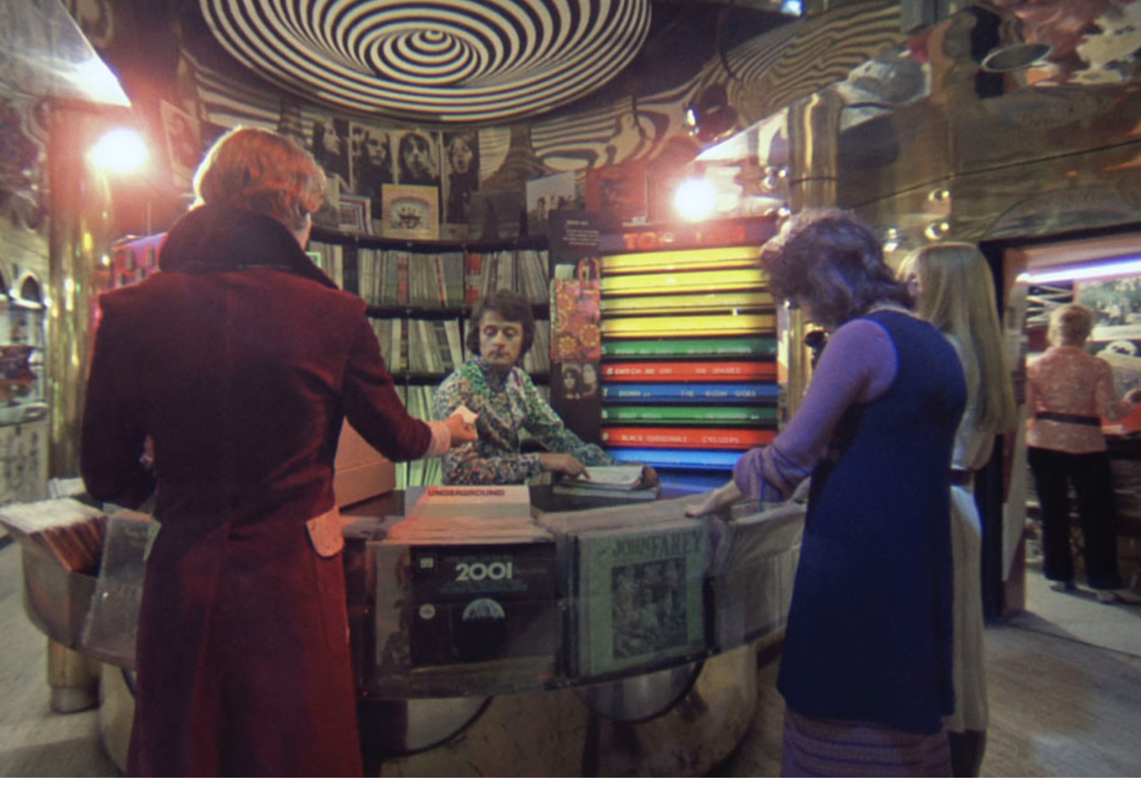

Feuilleton (2006). 2001: Space Odyssey Reference

Designing Buildings Wiki (2016). RIBA Architecture (2019). IMDb (2020). I believe Kubrick applied his photography knowledge to the cinematography in the movie (along with some of his other movies of course).
This particular movie not only captured the story’s plot and characters, but also the detail of the scenery and eeriness of the ‘dystopian future’ based in England, he tried to emphasize the world of Clockwork orange through his filming technique and location choices, which is why the brutalist architecture and cinematography were so important in this movie. Without those elements within the film, the audience wouldn’t have truly felt they would have been there through escapism or be able to understand the kind of world the characters were living in. Since this movie was an adaptation from the book ‘A Clockwork Orange,’ (written by Anthony Burgess) it was important for Kubrick to show the audience the world and the detail within it rather than explain it. This can be difficult with a lot of movie adaptations since it is hard to explain what is happening in a movie without the use of words and description, in this case cinematography should be taken seriously (which Kubrick had done successfully for this film) if you want your audience to understand it.

Summary

IMDb (2020). In conclusion, Kubrick was a Photographer, filmmaker and director, but overall, he was an artist. At a very early age of his life he already knew what he wanted to do, and although he did poorly in school, that certainly did not mean he was any less intelligent. Without him, ‘Spartacus,’ ‘2001: Space Odyssey,’ ‘Dr. Strangelove,’ all of these classics would have turned out to be classically mediocre, his approach towards the film industry revolutionised cinema in the 20th century and still remains to influence people today.

