Stanley Kubrick
Hannah Assefa

The essay aims to explain the importance of scenery in one of Kubrick’s films, this includes the discussion of certain architecture, movie referencing within a scene and of course the importance of Kubrick’s unorthodox cinematography methods which made this movie better and abstract and real.
Stanley Kubrick made a big impact on cinema in the 20th century. He became a photographer at the early age of seventeen and began filmmaking at twenty-two. From there his career would skyrocket, leading on to some of the greatest classics still remembered today.
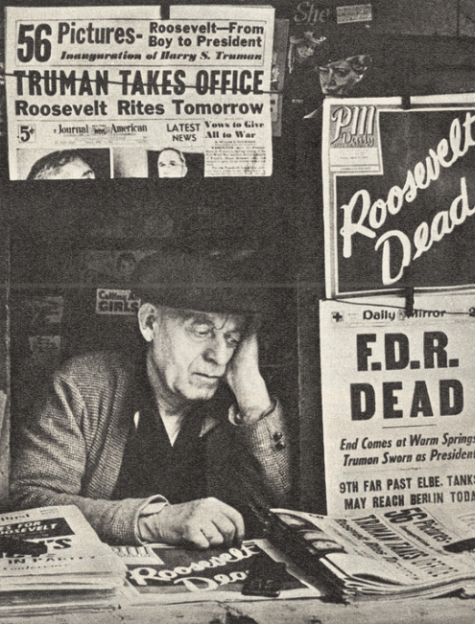
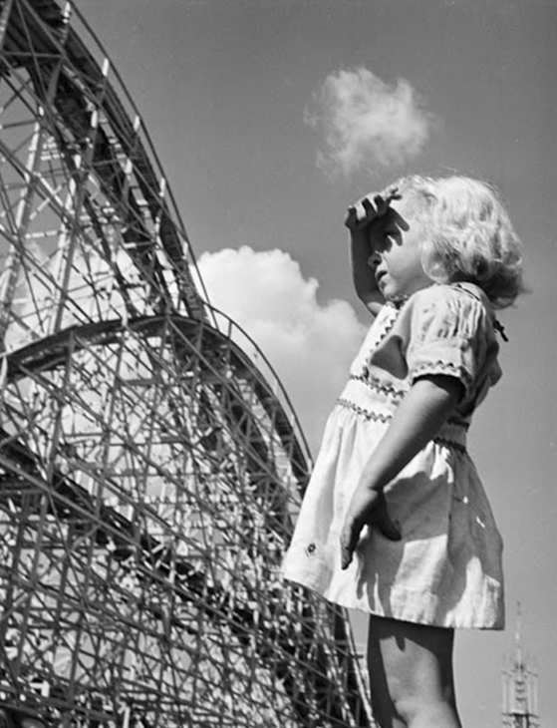
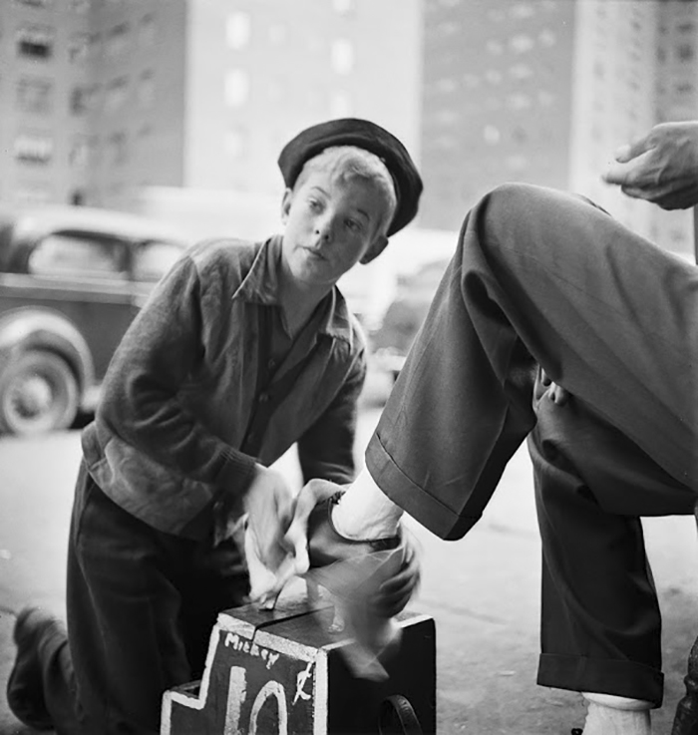
IMDb (2020). Kubrick was born On July 26th 1928 in New York city. He was seen as an intelligent child despite his low grades in school, so his father introduced him to chess, which led to a passion for the game and would aid him instead as a tool for his future career. At the age of thirteen, his father got him his first film camera for photography; from there, Kubrick began taking photos around the city and would develop the photos with a new-found friend (his neighbour) with the same passion for photography and a darkroom they could develop photos in. At the age of seventeen, Kubrick proved himself as a photographer and was accepted a job at ‘Look’ magazine. From there, he would start a 5-year career in photography.
Barber, N. (2018) Andrius (2018) Twistedsifter (2011)
Newspaper man, ‘Roosevelt dead’ Shoe-Shiner, New York city, Young girl in
Photo taken in 1945 1946 Palisades park, New
Jersey, 1946
IMDb (2020). In that time as a photographer, he became infatuated with moving pictures and with the help of his friend ‘Alexander Singer’, he would pursue this new profession. With the money he saved from his photography career, from 1950 he would save money for and create the documentary ‘Day of the fight’ which would be released in 1951, the same year, he would make his next documentary called ‘Flying Padre’ and in 1953 he would release ‘The Seafarers’ and ‘Fear and desire’ which this time was not a documentary but instead a thriller/war movie.
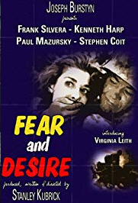

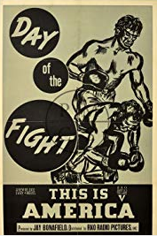

IMDb (2020). IMDb (2020). IMDb (2020).
Day of the Fight Flying Padre Fear and Desire

IMDb (2020). Kubrick went on to direct many other movies such as ‘killer’s kiss,’ ‘The killing.’ The movies that made him noticed in the film industry were ‘Paths of glory’ and ‘Spartacus,’ both movies that kickstarted his career as a director and filmmaker. Spartacus is possibly one of his most popular movies directed; It was in fact Kirk Douglas (who also played in ‘Paths of Glory’) who prompted him to direct the film. Although some of the crew members on set did not agree with his directing strategies in the movie, that did not stop Kubrick’s work and efforts he put into the production of the film. In 1961, the film got four academy awards and one Golden Globe award.

IMDb (2020). Not only did he do direct in the movie but subsequently did cinematography in the movie too. The original Cinematographer’s (Russell Metty) work was not up to Stanley Kubrick’s perfectionist standards for the film, so soon after he took over, this left Russell Metty doing practically nothing for the film and even had to accept a cinematography award for the movie he didn’t have part in.

His earlier movies were what led him to direct some of the most iconic movies in film history.

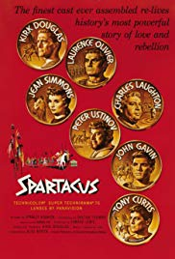
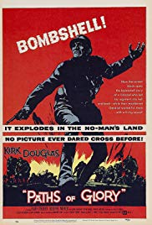

The movie ‘Paths of The movie ‘Spartacus’
Glory’ featuring also featuring Kirk
Kirk Douglas Douglas

Kubrick went on to direct some of the 60’s-70’s classics like ‘2001: Space Odyssey,’ ‘Dr. Strangelove,’ ‘Lolita,’ ‘Barry Lyndon’ and ‘Clockwork Orange.’

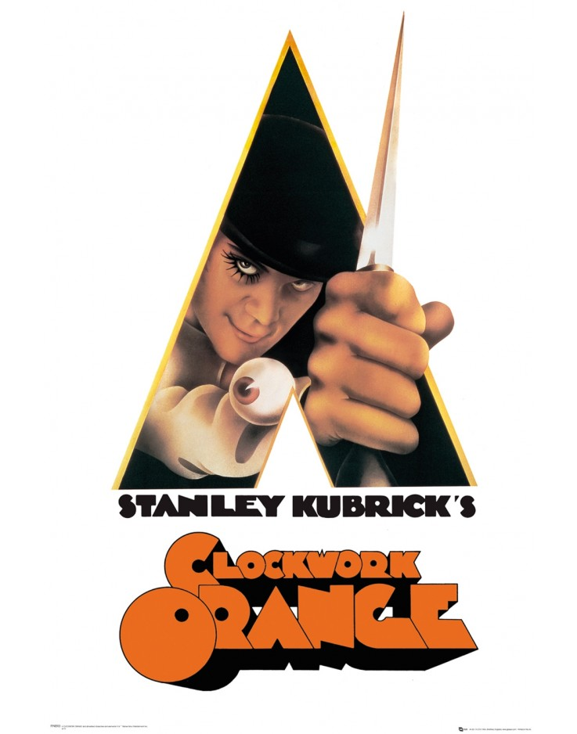

Movie-Locations (2020). Made in 1971, ‘Clockwork Orange’ is one of Kubrick’s iconic movies made. Clockwork Orange is the movie adaptation of the book which Kubrick read beforehand, the reason he made this into a movie was to prove to others he could make a low budget movie using existing locations, unlike his movie ‘2001: Space Odyssey,’ which cost 10.5 million US dollars ($) to make. He decided to make this movie to prove they don’t have to be so expensive, the film in total cost only 2.2 million dollars. Kubrick scouted London for locations and found many that would work well in the movie.

RIBA Architecture (2019). Stanley Kubrick uses ‘brutalism’ to appeal to the sci-fi nature of the movie. ‘Brutalism’ (also known as ‘Brutalist architecture,’) is a style that began around the 1950s but ended also within the 20th century because the style was ironically ‘brutal’ and unwelcoming in appearance (which is the very reason Stanley Kubrick used these buildings in his movie). The style tends to be ‘blocky’ and geometric in a sense everything that is a brutalist building looks like an abstract statue.
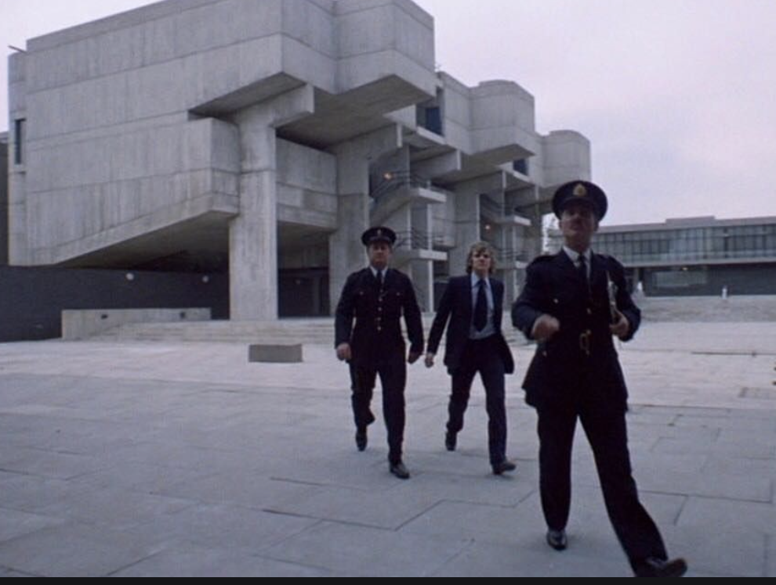
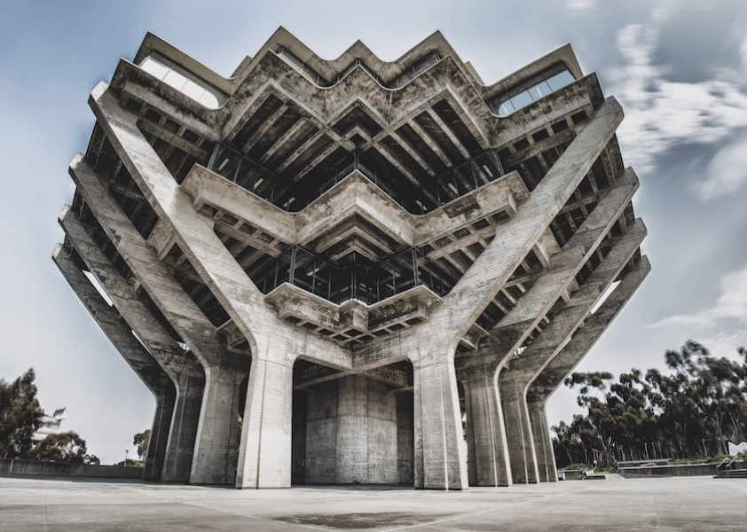

Stewart, J. (2018) Pinterest (2020)
Example: Brutalism Architecture Image of scene: ‘Alex’ being escorted to
experimentational therapy

Gallagher, B. (2018). The movie itself is in the sci-fi mystery genre and is based in dystopian England. The story in whole is narrated by the sociopathic gang leader (Alex who is played by Malcolm McDowell) and is also the main character of the film. He’s arrested and rehabilitated through a new ‘therapeutic’ method that goes wrong.

The cinematography of the movie is simplistic but engaging to the audience, the long shots captured everything in clear view and revealed detail in the film which made it seem so much more realistic, that was what made the movie special.
Feuilleton (2006). For example, the record shop scene in the movie was slow paced, the atmosphere was calm but still rather tense considering the scene was in public and the character unpredictable, when Alex passes the counter facing right in front of the camera, below you can see a reference to his last movie, a simple poster that read ‘2001.’ (In reference to ‘2001: Space Odyssey).

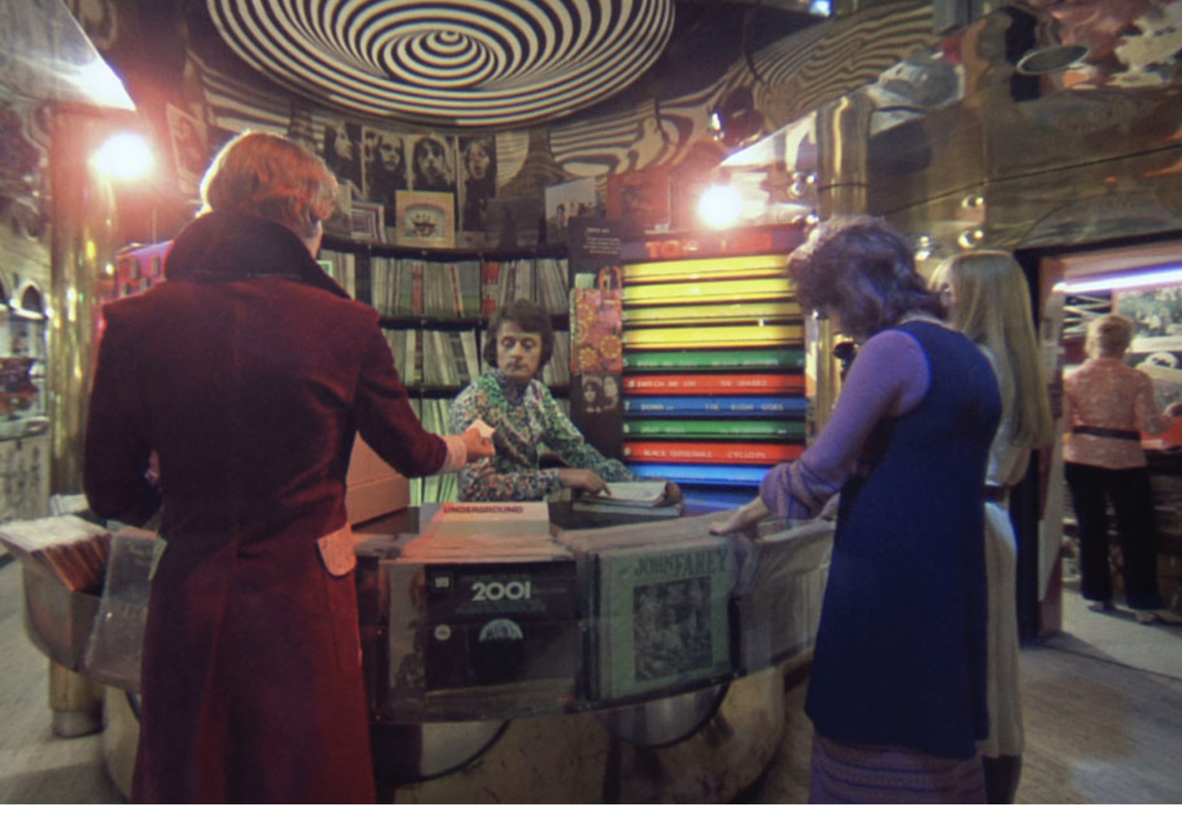

Feuilleton (2006). 2001: Space Odyssey Reference

I believe Kubrick applied his photography knowledge to the cinematography in the movie (along with some of his other movies of course). IMDb (2020) This particular movie not only captured the story’s plot and characters, but also the detail of the scenery and eeriness of the ‘dystopian future’ based in England, he tried to emphasize the world of Clockwork orange through his filming technique and location choices. RIBA Architecture (2019). This is why the brutalist architecture and cinematography were so important in this movie. Designing Buildings Wiki (2016). Without those elements within the film, the audience wouldn’t have truly felt they would have been there through escapism or be able to understand the kind of world the characters were living in. Since this movie was an adaptation from the book ‘A Clockwork Orange,’ (written by Anthony Burgess) it was important for Kubrick to show the audience the world and the detail within it rather than explain it. This can be difficult with a lot of movie adaptations since it is hard to explain what is happening in a movie without the use of words and description, in this case cinematography should be taken seriously (which Kubrick had done successfully for this film) if you want your audience to understand it.

In summary, Kubrick was a Photographer, filmmaker and director, but overall, he was an artist. At a very early age of his life he already knew what he wanted to do, and although he did poorly in school, that certainly did not mean he was any less intelligent. Without him, ‘Spartacus,’ ‘2001: Space Odyssey,’ ‘Dr. Strangelove,’ all of these classics would have turned out to be classically mediocre, his approach towards the film industry revolutionised cinema in the 20th century and still remains to be one of the greats today.
Stanley Kubrick has inspired me to become a better filmmaker and work hard in the industry. The purpose of this essay was to explore Stanley Kubrick’s cinematography which was heavily influenced by his photography career, I believe this because in ‘Clockwork Orange’ focuses heavily on the scenery in the movie like the milk bar, the record shop and of course the buildings. In most movies you will find a typical movie heavily depends on a narrative, whereas in this film it presents the abstract setting to the audience as if it were introducing you to dystopian England and it’s strange and blocky buildings (which made England look different and soulless), This is how he applied his photography experience and made the movie a lot better.

~~~~~~~~~~~~~~~~~~~~~~~~~~~~~~~~~~~~~~~~~~~~~~~~~~~~~~~~

1. - Andrius. (2018). 17-Year-Old Stanley Kubrick’s Photos Of 1940s New York Prove That He Was Born Genius. Available: https://www.boredpanda.com/vintage-photographs-new-york-street-life-stanley-kubrick/?utm_source=google&utm_medium=organic&utm_campaign=organic. Last accessed 13th Feb 2020.
2. - Barber, N. (2018). Stanley Kubrick, The Teenage Photographer.Available: https://www.1843magazine.com/culture/look-closer/stanley-kubrick-the-teenage-photographer. Last accessed 13th Feb 2020.
3. - Bewa, J. (2011). Graphic design – neon everything. Available: https://www.pinterest.co.uk/pin/77124212342051343/#. Last accessed 13th Feb 2020.
4. - Designing Buildings. (2016). Brutalism. Available: https://www.designingbuildings.co.uk/w/index.php?title=Brutalism&action=history. Last accessed 13th Feb 2020.
5. - Feuilleton. (2006). Alex in the Chelsea Drug store. Available: http://www.johncoulthart.com/feuilleton/2006/04/13/alex-in-the-chelsea-drug-store/. Last accessed 13th Feb 2020.
6. - Gallagher, B. (2018). Tracing the Style Influence of "A Clockwork Orange". Available: https://www.grailed.com/drycleanonly/a-clockwork-orange-style-influence. Last accessed 13th Feb 2020.
7. - IMDb . (2019). Stanley Kubrick. Available: https://www.imdb.com/name/nm0000040/. Last accessed 13th Feb 2020.
8. - IMDb. (2017). Top Ten Stanley Kubrick Movies. Available: https://www.imdb.com/list/ls062591885/. Last accessed 13th Feb 2020.
9. - Movie-Locations. (2020). A Clockwork Orange. Available: http://www.movie-locations.com/movies/c/Clockwork-Orange.php. Last accessed 13th Feb 2020.
10. - Riba. (2019). Brutalism. Available: https://www.architecture.com/explore-architecture/brutalism. Last accessed 13th Feb 2020.
11. - Stewart, J. (2018). Brutalism: What Is It and Why Is It Making a Comeback?. Available: https://mymodernmet.com/brutalist-architecture/. Last accessed 13th Feb 2020.
12. - Twisted Sifter. (2011). Stanley Kubrick’s Photos of New York Life in the 40s. Available: https://twistedsifter.com/2011/12/stanley-kubricks-new-york-photos-1940s/. Last accessed 13th Feb 2020.

